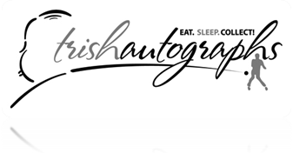

Contact: Trish Hessey
Tel. 909-484-8322
Email: trish@trishautographs.com FOR IMMEDIATE RELEASE

JOHNNY CASH PERSONAL CLOTHING, GUITAR, A COLLECTION EXCLUSIVELY
AVAILABLE FROM TRISH HESSEY AUTOGRAPHS
Trish Hessey Autographs has acquired a grouping of four items of unparalleled significance and opportunity that once belonged to Johnny Cash himself. Johnny Cash’s personal Bentley 6 string acoustic Guitar, beautifully hand signed by Cash. Model 5106 Serial No. S I 88101259 accompanied with his red guitar case.
TV Show- Stage Worn Suit: Black Jacket: Made By EAVES COSTUME CO. tag says; "MR. CASH/ #4538.
White Shirt: Made By TURNBULL & ABNER/ BERGDORFF GOODMAN/ LONDON
Black Pants: Made By MANUEL.
Exquisite Black Leather ankle boots, size 13D.
Outstanding full length black leather and suede coat with buffalo nickel buttons.
This is a rare opportunity that does not present itself to the public or private sector very often, this would be an sensational acquisition for the serious Cash fan or collector and/or a definitive presentation for an organization ready to display a piece of rock ‘n roll history! Johnny Cash defied a culture and helped usher in a new era in Memphis that redefined the landscape of America, giving his generation a face with his rebellious chords and distinctive vocals.
This collection is accompanied with COA’s from Bill Miller, owner and operator of Johnnycash.com, and CEO of Odyssey Group, Bill Miller is the undeniable leading authority on Johnny Cash. You can view the entire collection today directly at Trish Hessey Autographs or view our listing at EBay by copying and pasting the following link:
http://cgi.ebay.com/ws/eBayISAPI.dll?ViewItem&item=160371518371&ssPageName=STRK:MESELX:IT
If you would like more information about this topic, or to schedule an interview with Trish Hessey, please contact Russell Decotis at 909-319-8295 or email decotis@gmail.com. Please email Trish Hessey at trish@trishautographs.com

